  International Conference on Electrical Engineering/Electronics,  Computer, Telecommunications and Information Technology  ECTI-CON 2019, 10th – 13rd July 2019, Pattaya, Thailand | 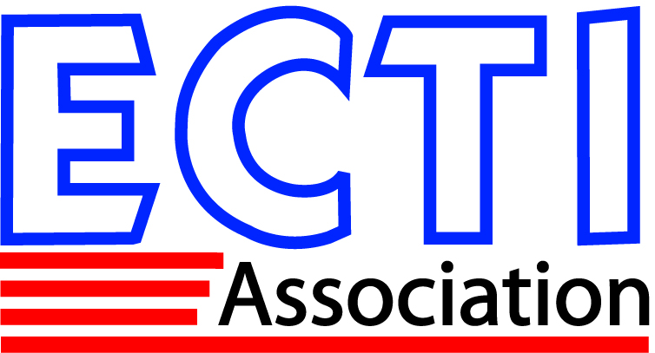

ECTI-CON 2019 Speaker Biography Form

Instructions: Please use this form to prepare a brief biography of the presenting author. This biography is meant to provide your session chairman with enough information to introduce you. One form is needed for every paper.

Paper ID:

Paper Title:

Speaker’s Name:

Affiliation:

Country:

Biography

- Current Status/Position:

- Education:

- Research Interests:

